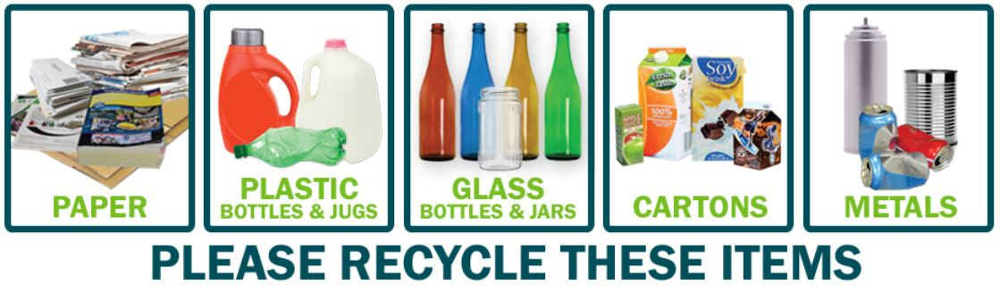

Acceptable Items for Recycling

- Glass Bottles & Jars (all colors)
- Metal Cans: Aluminum cans, steel cans and lids, empty aerosol cans with the lids and tips removed
- Plastic Bottles (empty, crush, reattach lid): Bottles and jugs that have a small mouth and wider base, such as milk jugs, soda bottles, laundry detergent bottles, water bottles, shampoo bottles and contact solution bottles
- Paper: newspaper, magazines, cardboard, mixed office paper and envelopes, paperboard (cereal boxes), pizza boxes free of food debris and grease, telephone books and catalogs
- Cartons: food and beverage cartons, such as milk, juice, soup, wine, broth and other cartons.

Recycling Tips

- Mix all items together – no separation required
- Empty all bottles, jugs and cans
- No need to remove labels
- For plastic bottles, empty, crush and reattach lids
- For cartons, remove plastic caps and straws
- NEVER place medical sharps or needles in the recycling
- DON’T use plastic bags

NOT for Recycling

- Garbage
- Food
- Yard waste
- Plastic bags
- Needles
- Syringes
- Electronics
- Buckets
- Butter tubs
- Light bulbs
- Drinking glasses
- Ceramics
- Batteries
- Pots
- Pans
- Scrap metal

